How to Create Your Own PTA/PTSA Value Message
You know the good work that your PTA does for your community every day—but talking about your accomplishments and inviting others to join you can be hard. This document will walk you through the steps you’ll need to follow to successfully ask anyone to join your PTA/PTSA!

Getting Started: Understanding Your Audience and Their Needs
There’s no one-size fits all way to talk about the value your PTA/PTSA brings, but according to research from our award-winning Membership Campaign, there are a few key tips.
- Always make an explicit Ask to Join
- Clarify what PTA membership means and that it is different from volunteering
- Remember that everyone belongs in PTA, and that everyone is interested, once they understand the association’s value and role
You are going to use the following three high-value areas as a starting point to create custom value message for the different audiences your PTA/PTSA wants to recruit.
Value 1: Our PTA/PTSA Creates Connections

May appeal most to those who are seeking to develop relationships and be “in the know” with what’s happening in school or the community at large. Consider referencing this value area when asking business leaders or new families at your school to join your PTA/PTSA.

Value 2: Our PTA/PTSA Supports Your Child
May appeal most to those who are always looking to discover new ways to support their children. Consider referencing this value area when asking administrators, teachers and parents/guardians who are not yet members to join your PTA/PTSA.
Value 3: Our PTA/PTSA Amplifies Your Voice

May appeal most to those who seek to affect policies and practices that impact the education, safety and well-being of children and youth. Consider referencing this value area when asking anyone, including students or community advocates, to join your PTA/PTSA.

The Three Key Questions: Showcasing Your PTA/PTSA’s Value
Once you’ve identified your audience and which of the value areas will appeal most to them, you’ll need to answer three key questions to create a complete PTA/PTSA Value Message:
- Why should I join the PTA/PTSA? [See worksheets for ideas/examples for all three value areas: Create Connections, Support My Child, and Amplify My Voice]
- Specifically, in what ways does the PTA/PTSA Create Connections, Support My Child, or Amplify My Voice? [See worksheets for ideas/examples]
- How do those ways benefit me/my child? [See worksheets for ideas/examples]
Don’t worry—the worksheets in this document contain answers for each question and will walk you through how to combine those answers to create an effective value message.

Instructions for Creating Your Value Message with the Worksheets
- Decide which of the three reasons would be most effective for your audience and navigate to the appropriate worksheet.
  - Page 3: Our PTA/PTSA Creates Connections
  - Page 8: Our PTA/PTSA Supports Your Child
  - Page 13: Our PTA/PTSA Amplifies Your Voice
- Consider how you’ll be speaking with your audience—in-person/virtual/hybrid, on social media, with a flyer, etc.—and select a long or short answer for the first question: Why should I join PTA/PTSA?
- Think about what motivates your audience and how they prefer to receive information. Then select a long or short answer from the list of options for the second question: Specifically, in what ways does PTA/PTSA [Create Connections, Support My Child, or Amplify My Voice]?)
- Match the answer you selected for second question with the appropriate examples/ideas we have provided to answer the third question: How do those ways benefit me/my child?
- Combine your answers and you’ll have a custom value message ready to go! Use the applicable templates, graphics and tools [Create Connections, Support My Child or Amplify My Voice] to share your custom PTA/PTSA value message with the audience you’re looking to recruit!
OUR PTA/PTSA CREATES CONNECTIONS

Step 1: Choose an Answer for Question 1, “Why Should I Join PTA/PTSA?”

Consider the method you’ll be using to communicate (social media, flyer, phone call, in-person/virtual/hybrid, etc.) with your audience when choosing the short or long opening statement.
You should join our PTA/PTSA because …
Short Answer | Long Answer
Your PTA/PTSA membership can help you build a village to support your child and connect you locally and nationally to a network that supports all children. | It’s true that it takes a village to raise a child—and our PTA/PTSA can help you build that village to support your child. Your membership will connect your family, our school and our community to a nationwide network of PTA members, who share resources, opportunities and tips to support your child and all children. We’re all in this together!

Step 2: Choose an Answer for Question 2, “In What Ways Does PTA/PTSA Create Connections?”
Think about what matters most to your intended audience. For example, you might select different answers for families that are new to your school than for local business or community leaders.
You’ll also need to think about how much time you’ll have with your audience—will you have enough time with them to get into the long answers?
When you belong to our PTA/PTSA, you’ll …
Short Answers | Long Answers
Meet and have fun with new people and families with kids your child’s age! | Meet new people in a fun, welcoming environment. You’ll connect with other families with kids your child’s age, your child’s teachers and school staff, some community leaders and more!
Connect to important school and community resources. | Connect to important school and community resources that you can use to support your child’s academic, social and emotional well-being.
Make connections in our community with other people who share your interests and concerns. | Make new connections within our community, in our state and even across the country who share your passion for and commitment to the health and welfare of all children.
Strengthen our community—we need your unique perspective to make a difference! | Strengthen your child’s community with your membership! We use your dues, ideas and feedback to do things like improve the school grounds and host events that create opportunities for your child.

Step 3: Match Your Answer from Step 2 with the Corresponding Example to Answer Question 3, “How Do the Ways that PTA/PTSA Creates Connections Benefit Me and My Child?
You know the saying, “Show, Don’t Tell?” This step is where that rule comes into play. The examples below provide details that back up the answer you selected in Step 2 and paint a more vibrant picture for your audience.
Do your best to help them imagine what PTA/PTSA membership could look like for them.
Being a PTA/PTSA member will help you…
Step 2 Answers | Step 3 Examples
Meet and have fun with new people and families with kids your child’s age! | Find time to make friends as an adult or get to know the parents of your child’s friends. Our PTA/PTSA events and meetings give you a fun place to get to know people and share ideas.
Connect to important school and community resources. | Access resources both inside and outside the school building, like [insert examples of things your PTA has done or intends to do. You can also give examples from National PTA, like the Guides to State Assessments, mental health resources from the Healthy Minds Program, or parenting news and tips from the Notes from the Backpack podcast].
Make connections in our community with other people who share your interests and concerns. | Get the chance to hang out and bond with other families at events and activities hosted by our PTA/PTSA. I think you’d enjoy our [insert examples your PTA/PTSA has done or intends to do, such as a Reflections student art program, STEM + Families Science Festival or Math Night, family game night, ice cream social, spring fair, etc.].
Strengthen our community and further grow as a parent—we need your unique perspective to make a difference! | Further grow as a parent and strengthen our community through education and awareness. Our PTA/PTSA hosts guest speakers on topics relevant to you and your family, like [insert examples that your PTA has done or intends to do, such as digital safety, healthy lifestyles or college and career readiness]. What would you like us to do next?

Step 4: Tie Your Answers Together!
At this point, you now have the answers to the three key questions:
- Why should I join PTA/PTSA?
- In what ways does PTA/PTSA Create Connections?
- How do those ways benefit me/my child?
Great work! All that’s left to do is to put them together and make any final edits or changes. Play with the drop-down menus in the paragraph below to see how it should work.
Create Your Value Message: Our PTA/PTSA Creates Connections
Here is an example:
You should join our PTA because your membership can help you build a village to support your child and connect you locally and to a nationwide network that supports all children. When you belong to our PTA, you’ll connect to important school and community resources. Being a member of our PTA will help you access resources both inside and outside the school building, like mental health resources from the Healthy Minds Program, or parenting news and tips from the Notes from the Backpack podcast. Will you support our efforts by becoming a member?
You should join our PTA because Choose an item. When you belong to our PTSA, you’ll Choose an item. Being a member of our PTSA will help you Choose an item. Will you support our efforts by becoming a member?

Share Your Value Message!
There are so many ways to use the value message you just created. Here are a few ideas, but the only limit is your imagination!
- Post it on social media with either the PTA or PTSA version of the PTA Creates Connections graphics
- Use it as a script at an upcoming event or as an “elevator pitch” when chatting with prospective members
- Create a custom flyer using either the PTA or PTSA version of the PTA Creates Connections Customizable Content Flyer Template! See the website for detailed instructions on how to use the templates. Below is an example of what yours might look like—for this example, we’ve used a generic QR code that goes to National PTA’s Find and Join My PTA Look Up page.
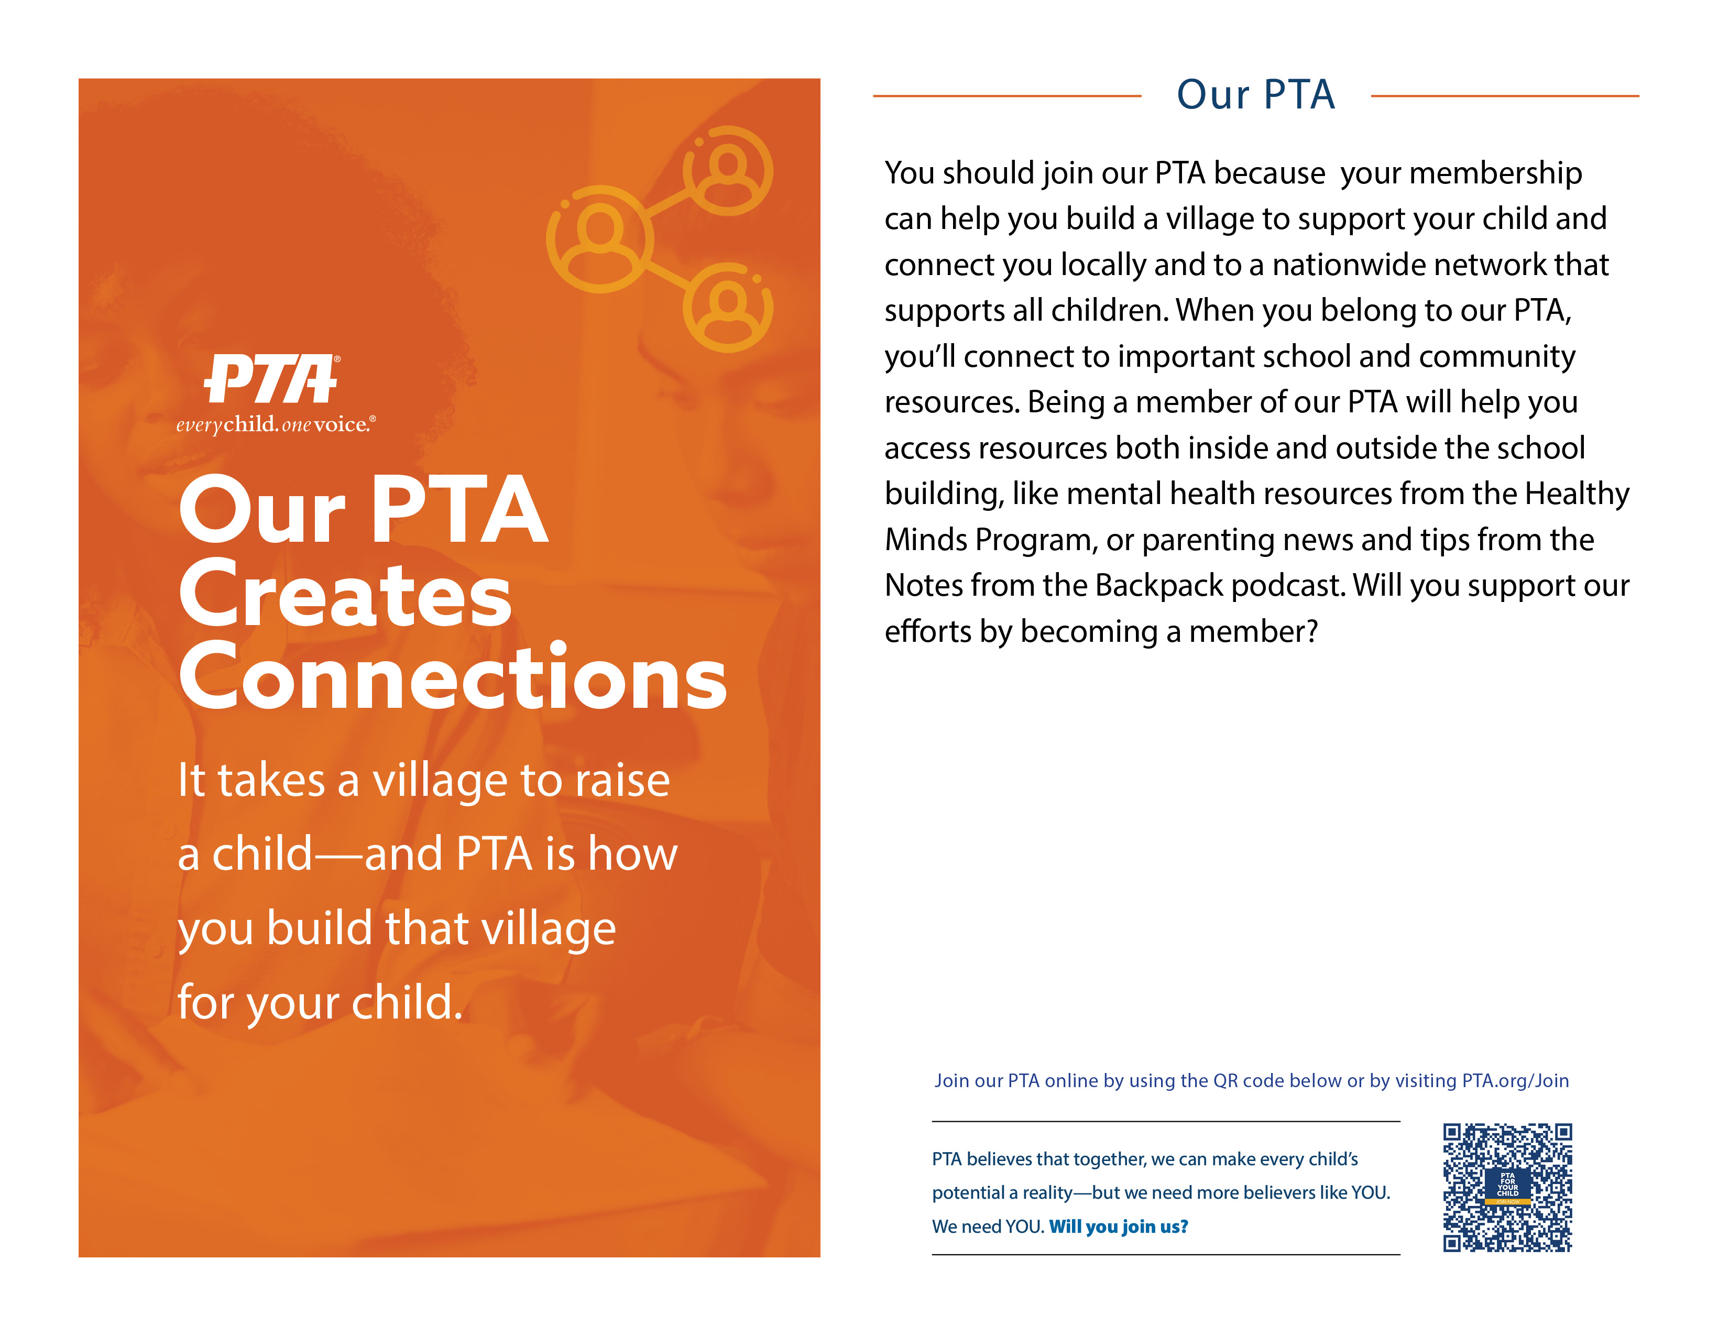

OUR PTA/PTSA SUPPORTS YOUR CHILD

Step 1: Choose an Answer for Question 1, “Why Should I Join PTA/PTSA?”

Consider the method you’ll be using to communicate (social media, flyer, phone call, in-person/virtual/hybrid, etc.) when selecting the length of your opening statement.
You should join our PTA/PTSA because …
Short Answer | Long Answer
Our PTA/PTSA supports your child with education, health and safety programs. | Our PTA/PTSA gives you the tools you need to support your child’s academic, social and emotional growth with data-backed education, health and safety programs.

Step 2: Choose an Answer for Question 2, “In What Ways Does PTA/PTSA Support My Child?”
Think about what matters most to your intended audience. For example, you might select different responses for families than for school administrators or teachers. Will you have enough time with them to get into the long answers?
When you belong to our PTA/PTSA, you’ll …
Short Answers | Long Answers
Gain access to resources that support whole child development in the arts and sciences; physical and mental health; digital safety and citizenship; and more! | Gain access to an extensive library of online resources on topics like:  - Family engagement and school improvement  - Testing and assessments  Physical and mental health  - Science, Technology, Engineering and Math (STEM)  - Digital safety and citizenship  - Reading/Literacy  - Support for children with special needs  - Diversity, equity and inclusion best practices  - College and career readiness  - And more!
Help to enrich your child’s experience in school by giving them the opportunity to participate in and enjoy nationally recognized PTA programs. | Help give your child the benefit of participating in nationally recognized PTA programs that are inspiring, educational and fun:  - STEM + Families (science, technology, engineering and math)  - Reflections (art education and competition)  - School of Excellence (family engagement and school improvement)  - Family Reading Experience (literacy)  - PTA Connected (digital safety, literacy and citizenship)  - Healthy Lifestyles and Healthy Minds (physical and mental health)  - And more!

Step 3: Match Your Answer from Step 2 with the Corresponding Example to Answer Question 3, “How Do the Ways PTA/PTSA Supports My Child Benefit Me/My Child?
You know the saying, “Show, Don’t Tell?” This step is where that rule comes into play. The examples below provide details that back up the answer you selected in Step 2 and paint a more vibrant picture for your audience.
Do your best to help them imagine what PTA/PTSA membership could look like for them.
Our PTA/PTSA helps you and your child by …
Step 2 Answers | Step 3 Examples
Gain access to resources that support whole child development in the arts and sciences; physical and mental health; digital safety and citizenship; and more! | - Providing engaging assemblies and programs to enhance education in school, like [insert examples your PTA/PTSA has done or intends to do. Be specific—writer or artist residency, historical assemblies, live music or dance performances, etc.]  - Encouraging a lifelong love of reading with [insert examples your PTA/PTSA has done or intends to do. Be specific—read-a-thons, guest reader events, family book clubs, book fairs, fundraisers for donations to the school library, classrooms or students, etc.]
Help to enrich your child’s experience in school by giving them the opportunity to participate in and enjoy nationally recognized PTA programs. | - Hosting a Reflections Art Program and recognizing the artistic efforts of all students who participate. Plus, winning Reflections artworks can advance to the state and then national level—your child might even be recognized by the U.S. Secretary of Education for their artistic talent!  - Sharing research-backed, easy-to-understand, and family-focused resources from the PTA Healthy Lifestyles program and using them to host [insert examples your PTA/PTSA has done or intends to do, like a panel discussion, guest speaker, mental health fair, etc.] so families like yours can learn how to deal with stress and help children build resiliency.

Step 4: Tie Your Answers Together!
You now have the answers to the three key questions:
- Why should I join PTA/PTSA?
- In what ways does PTA/PTSA Support My Child?
- How do those ways benefit me/my child?
Great work! All that’s left to do is to put them together and make any final edits or changes. Play with the drop-down menus in the paragraph below to see how it should work.
Create Your Value Message: Our PTA/PTSA Supports Your Child
You should join our Choose an item. because Choose an item. When you belong to our Choose an item., you’ll Choose an item. Our Choose an item.helps you and your child by Choose an item. Will you support our efforts by becoming a member?
Here is an example:
You should join our PTA because PTA supports your child with education, health and safety programs. When you belong to our PTA, you’ll gain access to resources that support whole child development in the arts and sciences; physical and mental health; digital safety and citizenship; and more! Our PTA helps you and your child by hosting guest reader events and book fairs and donating books to students to encourage a life-long love of reading. Will you support our efforts by becoming a member?

Share Your Value Message!
There are so many ways to use the value message you just created. Here are a few ideas, but the only limit is your imagination!
- Post it on social media with either the PTA or PTSA version of the PTA Supports Your Child graphics
- Use it as a script at an upcoming event or as an “elevator pitch” when chatting with prospective members
- Create a custom flyer using either the PTA or PTSA version of the PTA Supports Your Child Customizable Content Flyer Template! See PTA.org for detailed instructions. Below is an example of what yours might look like—for this example, we’ve used a generic QR code that goes to National PTA’s Find and Join My PTA Look Up page.
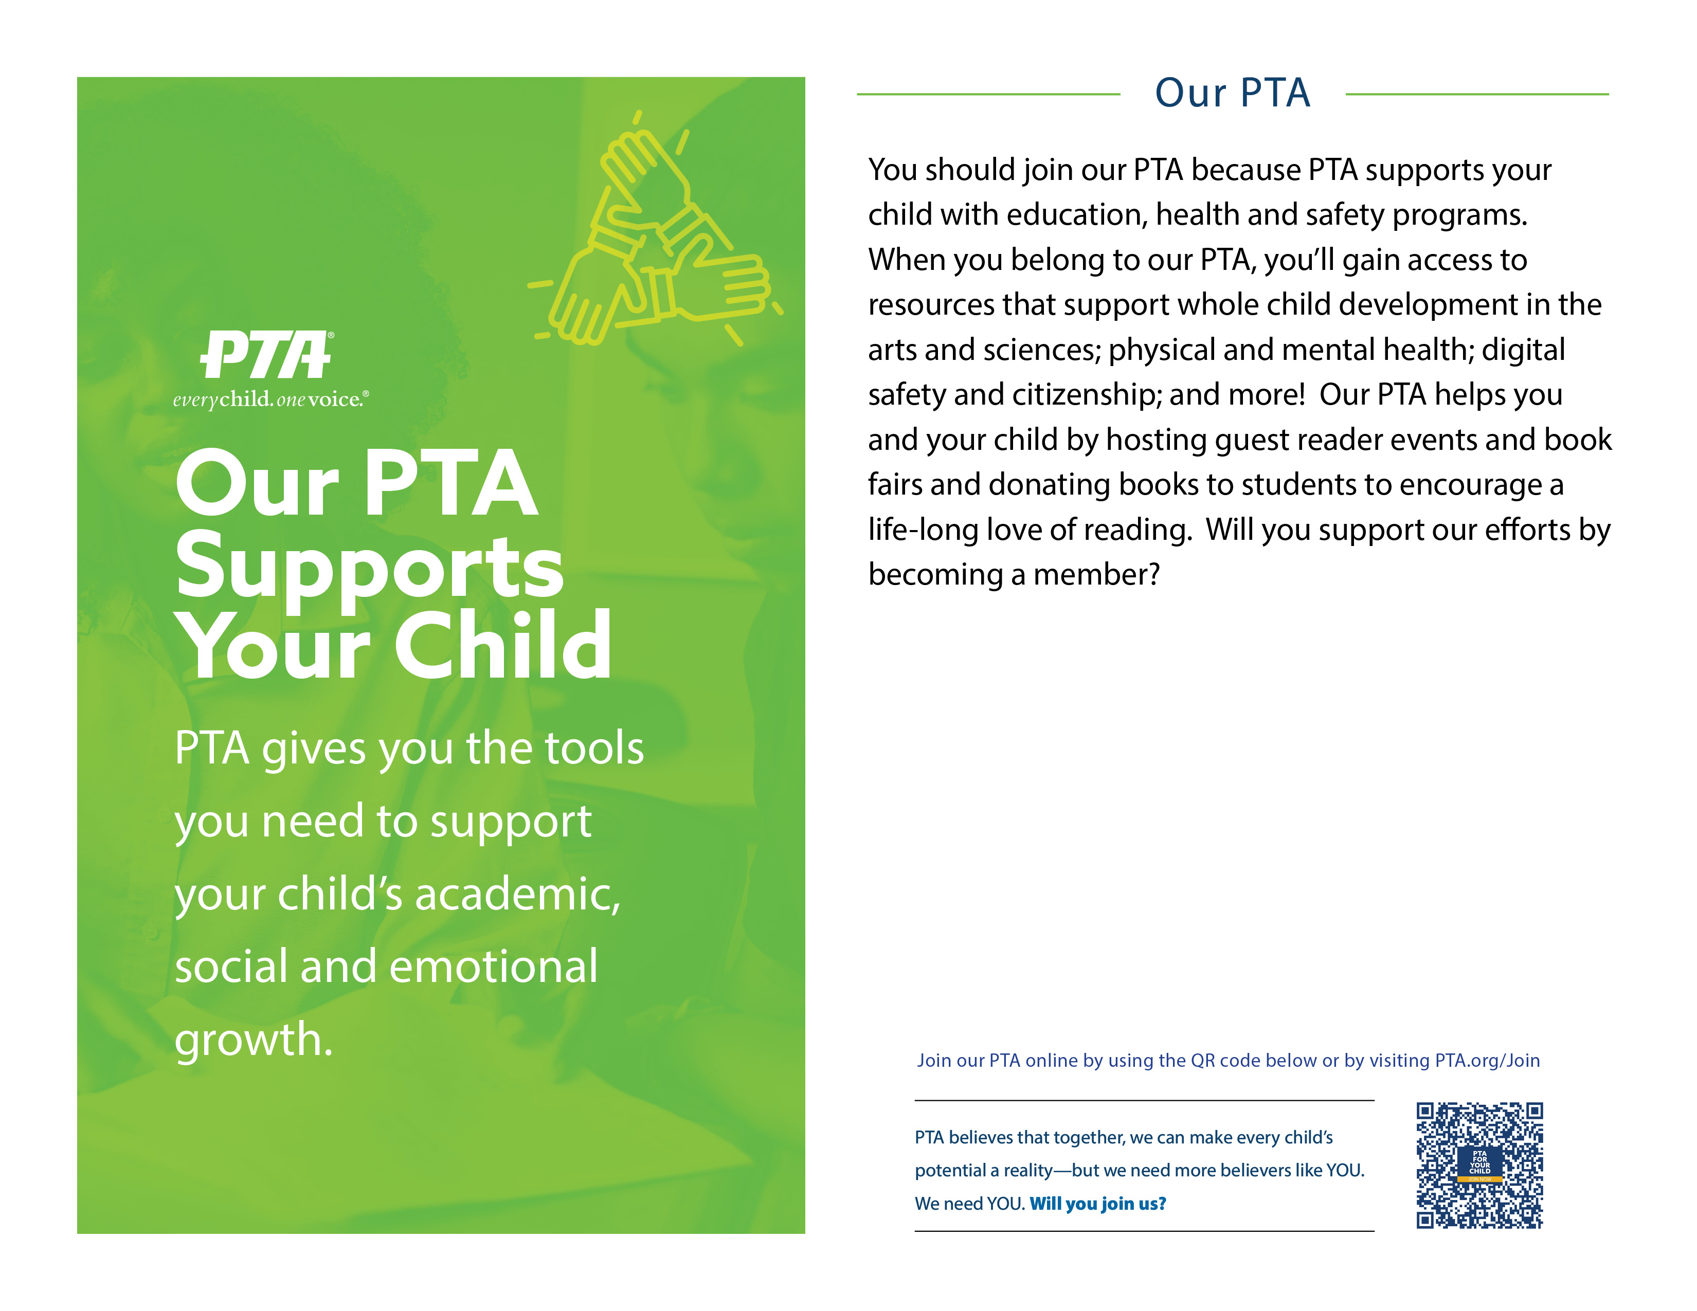
OUR PTA/PTSA AMPLIFIES YOUR VOICE

Step 1: Choose an Answer for Question 1, “Why Should I Join PTA/PTSA?”
Consider the method you’ll be using to communicate (social media, flyer, phone call, in-person/virtual/hybrid, etc.) when selecting the short or long opening statement.
You should join our PTA/PTSA because …
Short Answer | Long Answer
PTA amplifies your voice through collective impact. We can do more together than we can apart! | PTA amplifies your voice and has over 125 years of experience in using the power of collective impact to advocate for the health, safety and well-being of all children.



Step 2: Choose an Answer for Question 2, “In What Ways Does PTA/PTSA Amplify My Voice?”
Think about what matters most to your intended audience. For example, you might select different responses for families than for students or teachers. Will you have enough time with them to get into the long answers?
When you belong to our PTA/PTSA, you’ll …
Short Answer | Long Answer
Learn what you can do to positively impact students, families and schools, as well as education programs and services. | Learn what you can do to positively impact students, families and schools, as well as education programs and services, through regular updates and action alerts from our State and National PTA.
Enhance your knowledge and skills as an advocate. | Enhance your knowledge and skills as an advocate by gaining access to workshops, resources and training that will teach you how find and contact your elected officials, and what to do once you’ve got their attention.
Have a voice in decisions that affect you, your child and all children. | Have a voice in decisions that affect you, your child and all children by giving your feedback on education policy the collective bargaining power of not just our own PTA members, but millions of PTA members nationwide.
Connect with a nationwide network of PTA advocates and a wide array of influential individuals and organizations. | Connect with a nationwide network of PTA advocates and a wide array of influential individuals and organizations. The benefit of becoming part of an association that’s been around for over 125 years is that a lot of the legwork has already been done for you!
Strengthen your ability to support your child and serve all children and families. | Strengthen your ability to support your child and serve all children and families. Your membership dues fund advocacy efforts that change policies and laws in our city, our state and on Capitol Hill.

Step 3: Match Your Answer from Step 2 with the Corresponding Example to Answer Question 3, “How Does PTA/PTA Advocacy Benefit Me and My Child?
You know the saying, “Show, Don’t Tell?” This step is where that rule comes into play. The examples below provide details that back up the answer you selected in Step 2 and paint a more vibrant picture for your audience.
Do your best to help them imagine what PTA/PTSA membership could look like for them.
PTA advocacy helps you, your child and all children because …
Step 2 Answers | Step 3 Examples
Learn what you can do to positively impact students, families and schools, as well as education programs and services. | - Our PTA/PTSA attends school board meetings and keeps you informed of what is happening, and we share your voice when we speak at those meetings.  - You can sign up for the PTA Takes Action Network through National PTA, which will alert you to important federal policies and provide you with customizable, pre-written letters you can send to your members of Congress.
Enhance your knowledge and skills as an advocate. | - Our PTA/PTSA attends our State PTA’s legislative conference to sharpen our advocacy skills.  - National PTA offers print-and-go Issue Briefs on PTA’s Public Policy Priorities; free, on-demand advocacy training modules on their website; and competitively priced advocacy workshops at their annual Legislative Conference in Washington, DC.
Have a voice in decisions that affect you, your child and all children. | - Our PTA/PTSA invites our school’s principal to attend PTA meetings to share with and hear from you and others.  - Our PTA/PTSA hosts town halls and information nights so your voice can be heard by decision-makers, and you can make informed choices for your child.  - National PTA maintains a network of volunteer Federal Legislative Chairs who promote PTA’s federal public policy agenda and advocate on legislative issues that impact your family.
Connect with a nationwide network of PTA advocates and a wide array of influential individuals and organizations. | - Our PTA/PTSA attends state PTA legislative events to share your concerns with decision-makers.  - Our PTA/PTSA submits resolutions to our state PTA and/or to National PTA to make sure our voice is represented in their state and/or federal advocacy efforts.  - National PTA partners with organizations like the Human Rights Campaign, Everytown for Gun Safety, Learning First Alliance, etc.
Strengthen your ability to support your child and serve all children and families. | - PTA’s mission is to make every child’s potential a reality by engaging and empowering families and communities to advocate for all children. Your membership supports that mission!  - PTA is the nation’s oldest and largest volunteer child advocacy association. For over 125 years, PTA members have been behind historic achievements like child labor laws, the federal school lunch program, and more. Your membership supports PTA advocacy at our school, in our local community, in our state and on Capitol Hill.

Step 4: Tie Your Answers Together!
You now have the answers to the three key questions:
- Why should I join PTA/PTSA?
- In what ways does PTA/PTSA Amplify My Voice?
- How do those ways benefit me/my child?
Great work! All that’s left to do is to put them together and make any final edits or changes.
There were lots of answers for the PTA/PTSA Amplifies Your Voice category, so we’ve set up two paragraphs with drop down menus for you to experiment with—but you should feel free to mix and match the Local, State and National PTA advocacy talking points to suit your audience’s interests and your community’s unique needs.
Create Your Value Message: Our PTA/PTSA Amplifies Your Voice in Our Community
Here is an example:
You should join our PTA because Our PTA Amplifies Your Voice in Our Community. When you belong to our PTA, you learn what you can do to positively impact students, families and schools, as well as education programs and services. PTA advocacy helps you, your child and all children because our PTA attends school board meetings and keeps you informed of what is happening, and we share your voice when we speak at those meetings. Will you support our efforts by becoming a member?

You should join our Choose an item. because Choose an item. When you belong to our Choose an item., you’ll Choose an item. PTA advocacy helps you, your child and all children because Choose an item. Will you support our efforts by becoming a member?

Create Your Value Message: Our PTA/PTSA Amplifies Your Voice in Our State and on Capitol Hill
Here is an example:
You should join our PTA because Our PTA Amplifies Your Voice in Our State and on Capitol Hill. When you belong to our PTA, you connect with a nationwide network of PTA advocates and a wide array of influential individuals and organizations. PTA advocacy helps you, your child and all children because our PTA attends state PTA legislative events to share your concerns with decision-makers. Will you support our efforts by becoming a member?

You should join our Choose an item. because Choose an item. When you belong to our Choose an item., you’ll Choose an item. PTA advocacy helps you, your child and all children because Choose an item. Will you support our efforts by becoming a member?

Share Your Value Message!
There are so many ways to use the value message you just created. Here are a few ideas, but the only limit is your imagination!
- Post it on social media with either the PTA or PTSA version of the PTA Amplifies Your Voice graphics
- Use it as a script at an upcoming event or as an “elevator pitch” when chatting with prospective members
- Create a custom flyer using either the PTA or PTSA version of the PTA Amplifies Your Voice Customizable Content Flyer Template! See PTA.org for detailed instructions. Below is an example of what yours might look like—for this example, we’ve used a generic QR code that goes to National PTA’s Find and Join My PTA Look Up page.

